# Git Command

1. **Create Repository**

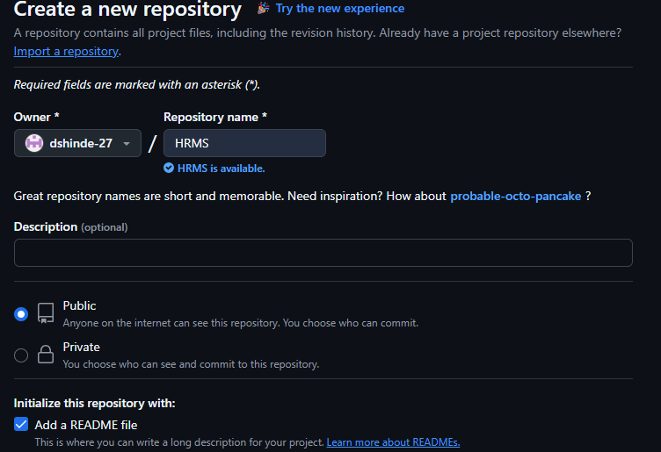

1. **Copy URL**

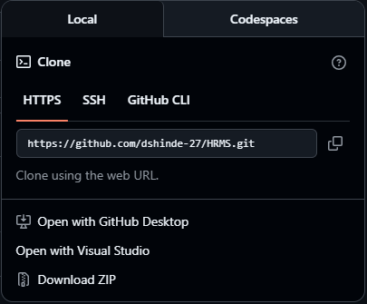

1. **And open folder wher you clone the repository and past url using command git clone**

git clone URL

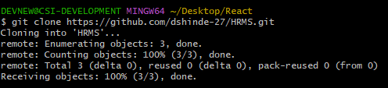

1. **Create Backend Folder**
2. **Open GitBash here**
3. **Type command “npm init -y”**

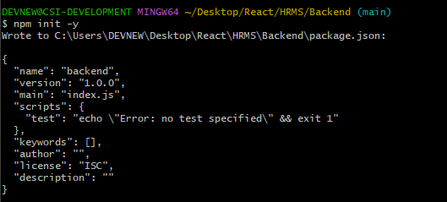

1. **Type command “npm install express”**

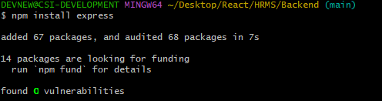

1. **Type command “npm install --save-dev nodemon”**nodemon (for auto-restarting server during development):

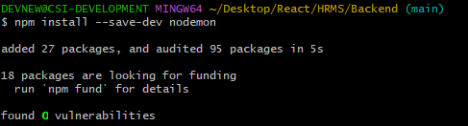

1. **Type command “npm install dotenv”** dotenv (for environment variables):

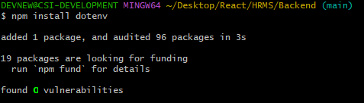

1. **Type command “npm install cors”** cors (if your API needs to be accessed from other domains):

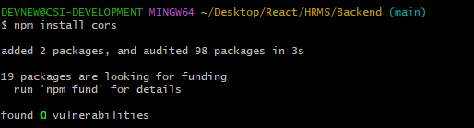

1. **Type command “npm install body-parser”** body-parser (often used to parse JSON or URL-encoded data):

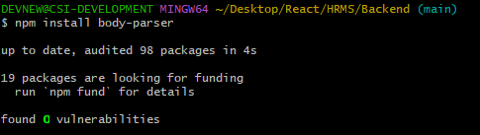

1. **Create a file**

Server.js

.env

.gitignore

1. **Type command**

**“echo "node_modules" >> .gitignore**

**“echo ".env" >> .gitignore**

The .gitignore file tells **Git** which files and folders it should **ignore** (i.e., **not track or upload** to GitHub).

1. **Git add .**
2. **Git commit -m “Add node js Api setup”**
3. **Git push**
4. **Git status**

